Parker launches blowout preventer hydraulic hoses
JUNE 9, 2017 BY MARY GANNON LEAVE A COMMENT
A line of blowout preventer hydraulic hoses was unveiled by Parker Hannifin at OTC last month. Designed for use topside, offshore and inland for oil and gas, these BOP hoses meet the API16D flame test and Lloyd’s Register 1499 test, said Michael Clark, business development manager for Parker Hannifin’s Fluid Connectors Group.
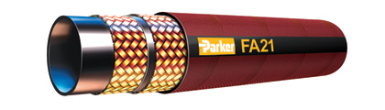They are available in a braided construction with a pressure rating of 3,000 psi, in size 6 to 16 (3/8 to 1 in.) or a spiral construction rated to 5,000 psi in sizes 6 to 32 (3/8 to 2 in.)
Parker had an external lab certify flame tests. The API16D flame test requires the hydraulic BOP hose to be pressurized to working pressure, and it must withstand a flame of 1,300°F for 5 minutes without losing any pressure. Lloyd’s 1499 is a similar test.
“We have three pillars to this offering,” Clark said. “This is how we differentiate ourselves. The first pillar is the product itself. It was imperative for us to meet the flame requirements of the API16D. We did that with special flame resistant materials on the cover.”
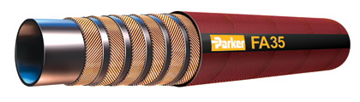Most BOP hoses are wrapped in fiberglass and then covered with stainless steel to meet those flame tests. Although Parker does offer a traditional BOP hose that is wrapped in a stainless-steel cover, the non-armored designs use a special jacketing material to meet the flame resistance tests.
“Some people don’t like change, or they want some protection for external abuse in offshore, so some people still want the stainless steel,” Clark said. “So what we did was we just designed it so it would go right over top of the hose. There is no fiberglass or anything there, so it’s the one hose that’s already rated and we’re just adding to it.”
The second pillar was not only meeting the API16D flame test but also meeting Lloyd’s Type approval, which Clark said is the highest approval you can achieve on a product like a hose. A Type Approval from Lloyd’s Register demonstrates that a product conforms to recognized industry quality standards, International Conventions and/or the LR Rules, through a process of independent design review, sample testing and verification of production controls.
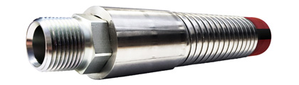“When Lloyd’s does Type Approval, what they do is they come in and they inspect your manufacturing process, and they give you approval on that. They inspect your testing facilities and how you’re running tests to make sure everything’s calibrated and you’re doing everything properly,” he said. “They witness your assembly locations and make sure that they are trained and that they have a quality process in place, and they sign off on that. When those three things are complete, then you can get Lloyds type approval.”
Parker is also in the process of having several key distributors also certified to Lloyd’s Type Approval.
Finally, the third pillar is on the preventative maintenance side, which relies on Parker’s PTS Pro (Parker Tracking System), to recommend or schedule maintenance. The PTS system uses coded tracking labels and RFID technology to keep track of a hose assembly, so it is quickly identified for replacement. It allows users to easily maintain a database of their hose assembly types, styles and how long they have been in use.
“BOP’s can go out in the field and we’re seeing a lack of accountability on when they were put into service and when they’re being replaced,” Clark said. “Using the PTS to schedule that maintenance, we can at the very least give our customers a notification saying it’s been in service for whatever length of time they would want to specify, and let them know that it’s time to either inspect or replace that hose. That’s something that separates us from our competition.”

